09th October 2017

**Petr Fulin is crowned 2017 FIA European Touring Car Cup Winner**

A splendid home victory in Race 2, of the FIA ETCC, which boasts the Japanese premium Tyre manufacturer YOKOHAMA as exclusive tyre supplier, delivered the Czech driver the title at the Race of Most held at the weekend. With a comfortable win thanks partly to the misfortune of title rival Christjohannes Schreiber who crashed his Rikli Motorsport Honda Civic while challenging Igor Stefanovski for the lead on lap six of Race 2. This meant Stefanovski’s SEAT was delayed by the contact, and Fulín made full use of the opportunity to zoom past and made good his escape to secure the ETCC title in superb fashion.

Earlier in Race 1, the Bulgarian Plamen Kralev was denied of his maiden victory in the FIA European Touring Car Cup after stewards decided to hand him a 10-second penalty for causing a collision with Christjohannes Schreiber's Honda Civic. However the provisional victory for the Kraf Racing Audi RS3 LMS only followed drama between title contenders Fulín, Nagy and Stefanovski. Following a delayed start, the Rikli Motorsport Honda Civic of Schreiber took the lead only for the Swiss to slip off the track at Turn 2. That left Nagy, Fulín and Stefanovski to battle at the front of the field. At the start of lap two, Fulín made a move on Nagy for the lead at Turn 1 and made it stick. Now the trio began to build a gap to the rest of the field led by a recovering Schreiber and Kralev. The turning point of the race came on lap seven when Stefanovski in his SEAT León Cup Racer passed Nagy on the outside of Turn 1, then punted hard into Fulín as they negotiated Turn 2. When they had sorted themselves out, Stefanovski now led from Nagy and the SEAT of Fulín. Stefanovski was penalised for his move and was handed a drive-through penalty, which dropped him to eighth and out of title contention with Race 2 to come. After the incident, Kralev closed in on the top three having already got past Schreiber – in a move that was later deemed unnecessary by the race stewards – and found his way around both Nagy and Fulín. With Stefanovski out of the picture, the Audi driver was all clear to claim a first win in the ETCC, which was later handed to Nagy, with Fulín second in the final classification and Schreiber third. The time penalty dropped Kralev down to fourth place. Schreiber's result kept him in mathematical contention for the 2017 ETCC crown ahead of what looked certain to be a thrilling season climax in Race 2. Fulín now had 70 points, three ahead of Nagy, with Schreiber a further three behind. In the end, it was a clear victory for Petr Fulin.

Meanwhile a spokesman for YOKOHAMA Europe extended congratulations to Petr Fulín and his team on their superb achievement. “It has been another exciting season at the FIA ETCC full of fair competition and the typical motorsports drama all along”. Congratulations to the top three and better luck for the next season to the other competitors.

Final standings

1 Petr Fulín 82

2 Norbert Nagy 75

3 Christjohannes Schreiber 65

4 Igor Stefanovski 60

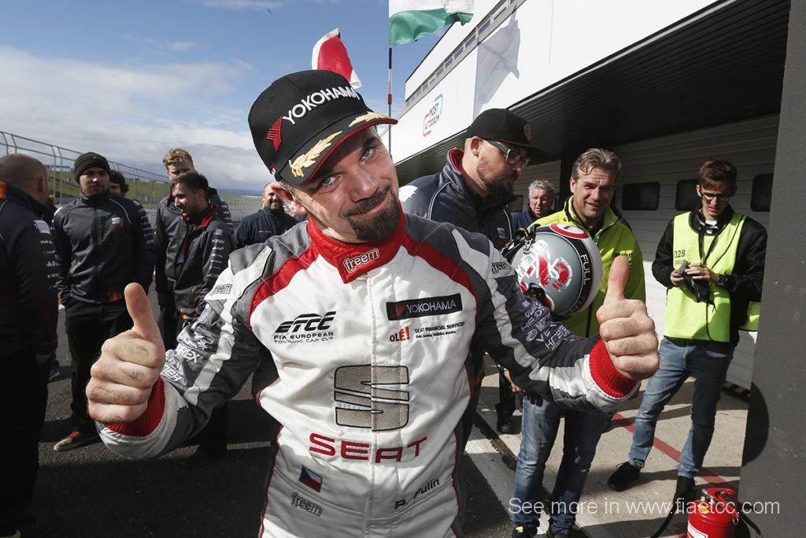

*Petr Fulin wins the FIA ETCC*

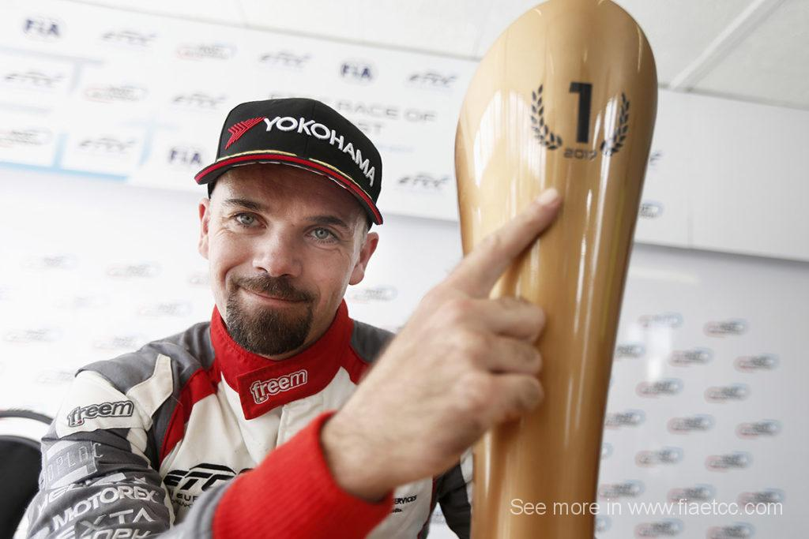

*Fulin showing his FIA ETCC Title Trophy*